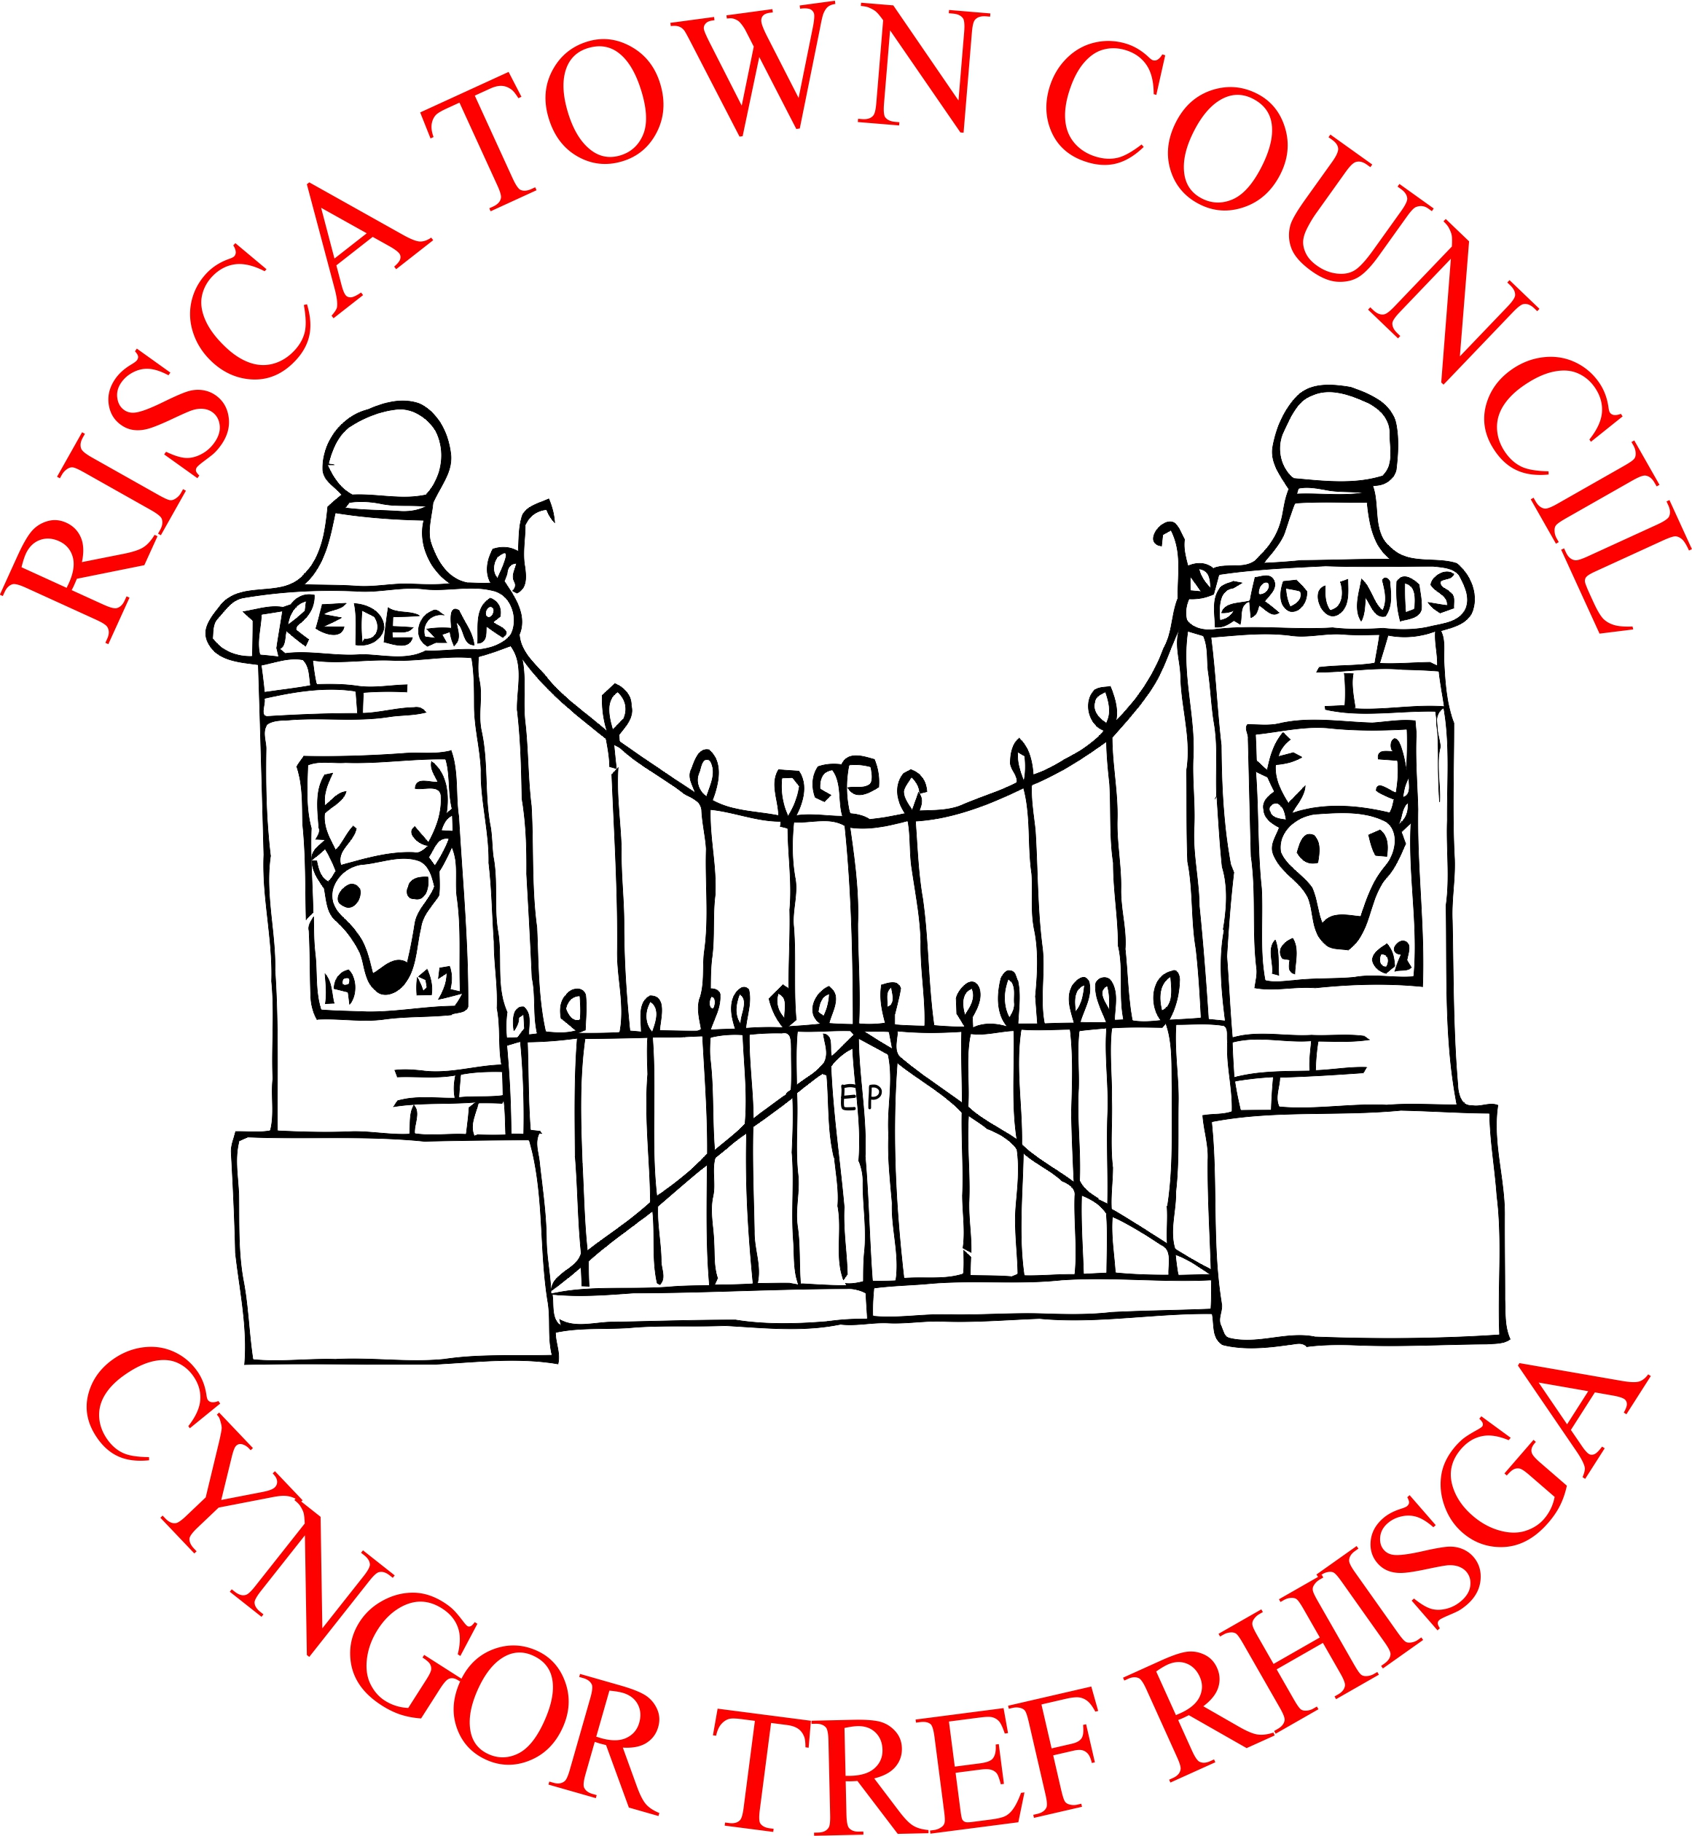

Cycle of Meetings for 2021/22

Meetings start at 6.30pm at Bethany Baptist Church
Members of the public are very welcome to attend
(health crisis dependent)

Date | Description
Mon 12th April 2021 | Held via a remote virtual platform due to the health crisis/lockdowns
Mon 10th May 2021 | Annual General Meeting held via a remote virtual platform. - Full Council also held via a remote virtual platform
Mon 14th June 2021 | Full Council to be held via a remote virtual platform
Mon 12th July 2021 | Full Council to be held via a remote virtual platform
AUGUST | RECESS
Mon 20th September 2021 | Full Council via a remote virtual platform or in person if new Welsh Govt regulations allow
Mon 11th October 2021 | Full Council via a remote virtual platform or in person if new Welsh Govt regulations allow
Mon 8th November 2021 | Full Council via a remote virtual platform or in person if new Welsh Govt regulations allow
Mon 13th December 2021 | Full Council via a remote virtual platform or in person if new Welsh Govt regulations allow
Mon 10th January 2022 | Full Council provisionally at Risca Senior Citizens Hall
Mon 14th February 2022 | Full Council at Risca Senior Citizens Hall
Mon 14th March 2022 | Full Council at Risca Senior Citizens Hall
Mon 11th April 2022 | Full Council
Mon 9th May 2022 | Annual General Meeting & Full Council

