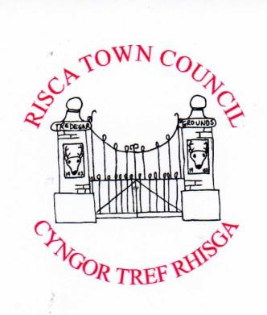
c/o Risca Palace Library, 75 Tredegar Street, Risca, NP11 6BW Office Opening Hours: Mon 2.00 pm - 5.40 pm
Tel: 07779906517 www.riscatowncouncil.org.uk
Town Clerk /RPO: Bob Campbell. email clerk2riscatc@gmail.com or bob.campbellriscatc.uk

Risca Town Councillor Vacancy by Co-option
Risca Town Council has a vacancy for a Town Councillor for its RisaTown and Fernlea Ward in the Town. The Council are seeking applications from residents and business people in the Town to fill this vacancy to bring the Council’s full complement up to eight Councillors.
Criteria - To qualify you must be at least 18, a British citizen or a Commonwealth or European Union citizen, a local elector, or have lived, worked or owned property in the community or within 4.8 kilometres of it, for a year.
The Council works voluntarily for the local community of Risca Town with its projects and events. A small remuneration is awarded annually to the Council Members. The term of office is for four years up to the next local elections set for May 2027. Candidates do not need local government experience but a strong commitment to the local community is essential.
If you are interested in working for and representing your Town then please contact Bob Campbell, Risca Town Clerk for more information. You can email anytime or telephone the Clerk to make an appointment to meet him at the Council’s office at Risca Palace Library 2.30 pm - 5.00 pm on Monday 26 June, Monday 3 July and Mon 10 July 2023. Applications need not necessarily be in a formal format however a personal resume in a few sentences via email at any time or delivered by hand will be necessary for the Council to consider.
The closing date for applications is 12 noon on Friday 7 July 2023
Bob Campbell, Risca Town Clerk – 19 June 2023

