Risca Town Council c/o Risca Palace Library,
75 Tredegar Street, Risca, NP11 6BW
Office Opening Hours: Mon 2.00 pm - 5.40 pm
Tel: 07779906517
www.riscatowncouncil.org.uk
Town Clerk/RPO: Bob Campbell
Email clerk2riscatc@gmail.com or bob.campbell@riscatc.uk
-------------------------------------------------------------------------------------------------------------------------------------------------------1 7 April 2025
To: The Mayor and Members of Risca Town Council
Dear Mayor/Councillor
You are requested to attend a monthly meeting of Risca Town Council in person or via a remote application:
Date - Monday 14 April 2025 at 6.30 pm. via an in-person indoors meeting at Bethany Church Hall (or via a TEAMS online application by prior arrangement of at least 3 working days with the Clerk).
The business to be transacted is set out in the agenda below.
Yours sincerely
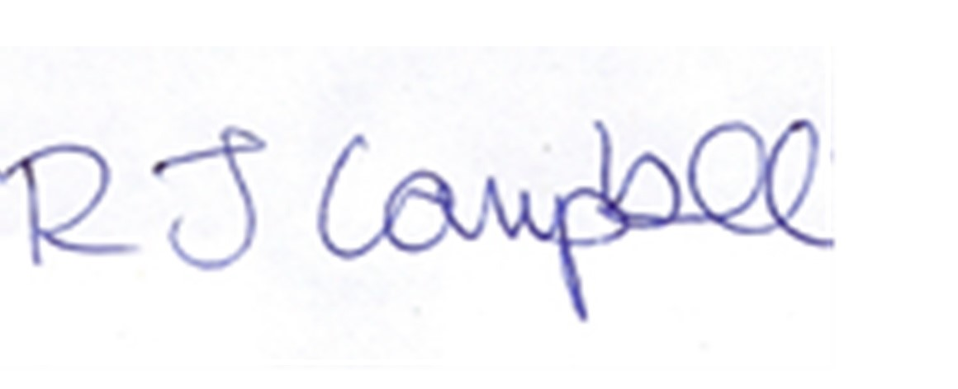
Bob Campbell
Clerk to the Council / Proper Officer

AGENDA
1/ Police update (possible attendance)

2/ Presentations (Cancer Research UK, Risca committee)

3/ Apologies

4/ Residents representations (none expected)

5/ Declarations of Interest

6/ Mayor’s Announcement

7/ Minutes and matters arising (if not already on the Agenda)
To receive and to confirm the minutes of the Full Council meeting held on 10 March 2025

8/ County Members’ Update

9/ Clerk’s Report / Correspondence
- Finance Report – with a bank account summary
- OVW/TCCLC update –
- Financial assistance requests –
- Correspondence –
- WG and CCBC update, Members’ vacancies

10/ Current Projects

Project No. | Project Name | Description & Comments | Amount Paid | Amount Pledged
A | PA system | For use at Town projects/events |  | 3000
B | VE Day 80 years and VJ Day 80 years | Risca RBL led events May and June |  | 1600
C | Bands in the Park | Sunday 20 July with Crosskeys Silver Band |  | 700

11. Planning Applications - Appendix 2

12. Motion to Exclude the Press and Public

13. Exempt items

14. Next Meeting
The next Meeting of the Council is the 2025 AGM set for 6.00 pm, Monday 12 May 2025 followed by the May Full Council meeting at 6.30 pm, both via in-person indoors meetings with added remote virtual access (only on written request with 3 working days prior notice to the Clerk).
A provisional date for a Joint Projects meeting for Risca Town Council and Risca East Community Council has not yet been agreed
Appendix 1 Mayor’s announcement if available as a written report
Appendix 2 Planning Applications –
Case Ref. 25/0166/FULL : buffel@caerphilly.gov.uk Expected Decision Level: Delegated Location: Site Area: 9970m² Land Off Commercial Street Birds Industrial Estate Pontymister Risca (UPRN 000043171098) Proposal: Erect a class A1 retail foodstore with surface-level car parking, landscaping, all associated development Case Officer: Anthony Pyne Ward: Risca West Map Ref: ( 01443 864523 324420 (E) 189857 (N) Community Council: Risca Town Council Case Ref. 25/0168/LA : pynea@caerphilly.gov.uk Expected Decision Level: Delegated

