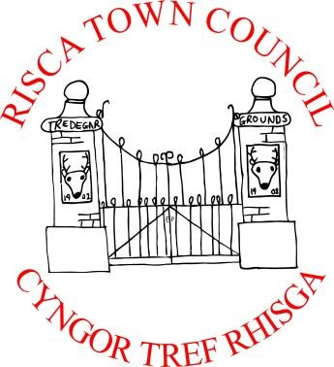

**Cycle of Meetings for 2025/26**

**Meetings generally start at 6.30pm at Bethany Baptist Church**

***Members of the public are very welcome to attend***

Hybrid format will be made available on prior request of at least 3 working days to the Clerk

|  |  |
| --- | --- |
| **Date** | **Description** |
| Mon 14th April 2025 | Completed |
| **Mon 12th May 2025** | 6 pm start for Annual General Meeting followed by Full Council |
| Mon 9th June 2025 | Full Council |
| Mon 14th July 2025 | Full Council |
| **AUGUST** | **RECESS** |
| Mon 8th September 2025 | Full Council |
| Mon 13th October 2025 | Full Council |
| Mon 10th November 2025 | Full Council |
| Mon 8th December 2025 | Full Council |
| Mon 12th January 2026 | Full Council |
| Mon 9th February 2026 | Full Council |
| Mon 9th March 2026 | Full Council |
| Mon 13th April 2026 | Full Council |
| **Mon 11th May 2026** | **6.00 pm Annual General Meeting & 6.30 pm Full Council** |

**Bob Campbell, Risca Town Clerk**

**For AGM 12 May 2025**

**Dated - 2 May 2025**