Risca Town Council c/o Risca Palace Library,
75 Tredegar Street, Risca, NP11 6BW
Office Opening Hours: Mon 2.00 pm - 5.40 pm
Tel: 07779906517
www.riscatowncouncil.org.uk
Town Clerk/RPO: Bob Campbell
Email clerk2riscatc@gmail.com or bob.campbell@riscatc.uk
-------------------------------------------------------------------------------------------------------------------------------------------------------1 3 November 2025
To: The Mayor and Members of Risca Town Council
Dear Mayor/Councillor
You are requested to attend a monthly meeting of Risca Town Council in person or via a remote application:
Date - Monday 10 November 2025 at 6.30 pm. via an in-person indoors meeting at Bethany Church Hall (or via a TEAMS online application by prior arrangement of at least 3 working days with the Clerk).
The business to be transacted is set out in the agenda below.
Yours sincerely
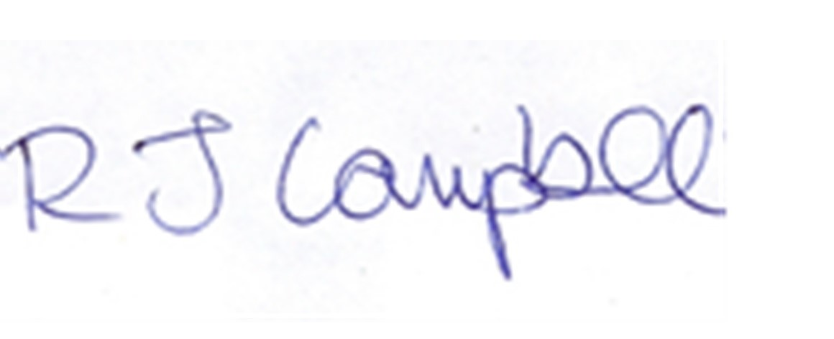
Bob Campbell
Clerk to the Council / Proper Officer

AGENDA
1/ Police update (possible attendance)

2/ Presentations (none planned)

3/ Apologies

4/ Residents representations (none expected)

5/ Declarations of Interest

6/ Mayor’s Announcement

7/ Minutes and matters arising (if not already on the Agenda)
To receive and to confirm the minutes of the Full Council meeting held on 13 October 2025

8/ County Members’ Update

9/ Clerk’s Report / Correspondence
- Finance Report – with a bank account summary and 24/25 Audit Return outcome
- OVW/TCCLC update – CCBC street lighting/Festive Lanterns certificates, CCBC digital totem in Tredegar Park, CCBC request to take on their ‘events’
- Financial assistance request –
- Correspondence –
- Community Topics –
- WG and CCBC update, Members’ vacancies

10/ Current Projects

Project No. | Project Name | Description & Comments | Amount Paid | Amount Pledged
A | PA system | For use at Town projects/events |  | 3000
B | New street lighting sockets for the Festive Lanterns | For this year |  | 3500
C | Winter Fair | Sat 22 Nov 2025 |  | 14000
D | Festive Lanterns project |  |  | 7000
E | Festive Windows comp. |  |  | 300

11. Planning Applications - Appendix 2

12. Motion to Exclude the Press and Public

13. Exempt items

14. Next Meeting
The next Meeting of the Council is set for Monday 8 December 2025 at 6.30 pm, via an in-person indoors meeting, with added remote virtual access (only on written request with 3 working days prior notice to the Clerk).
A provisional date for a Joint Projects meeting for Risca Town Council and Risca East Community Council has not yet been agreed
Appendix 1 Mayor’s announcement if available as a written report
Appendix 2 Planning Applications –
Case Ref. 25/0331/HH ( 01443 864429 Map Ref: 320629 (E) 196745 (N) : berrol@caerphilly.gov.uk Location: Site Area: 206m² 3 Lyne Road Pontymister Risca Newport NP11 6AT (UPRN 000043072540) Proposal: Erect single storey rear extension Case Officer: Lorna Berrow ( 01443 864429 Ward: Risca West Map Ref: Community Council: Risca Town Council 324179 (E) 190300 (N) : berrol@caerphilly.gov.uk Expected Decision Level: Delegated
Case Ref. 25/0690/COU : Location: Site Area: 129m² 4 Commercial Street Pontymister Risca Newport NP11 6AY (UPRN 000043070787) Proposal: Change the use of single dwelling into two self-contained flats Case Officer: Josie Millson ( 01443 864708 Ward: Risca West Map Ref: Community Council: Risca Town Council 323977 (E) 190252 (N) : milsoj@caerphilly.gov.uk Expected Decision Level: Delegated
Case Ref. 25/0732/ADV : braite@caerphilly.gov.uk Expected Decision Level: Delegated Location: Site Area: 16m² Tredegar Street Risca (UPRN 000043180684) Proposal: Erect a 75 inch, sub-surface mounted, outdoor, double sided digital totem Case Officer: Eric Wichert ( 01443 864709 Ward: Risca West Map Ref: Community Council: Risca Town Council 323882 (E) 190446 (N) : wichee@caerphilly.gov.uk Expected Decision Level: Delegated

