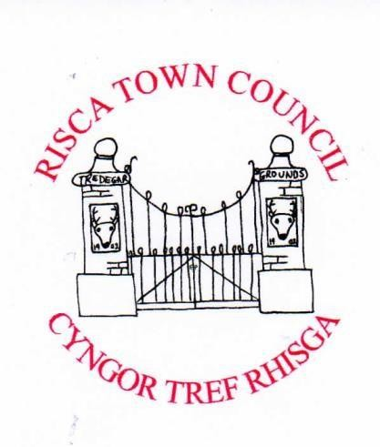














C/o Risca Palace Library,

75

Tredegar Street, Risca, NP11 6BW

Office Opening Hours:

Monday 2

.

00

pm

-

5.

4

0

pm

Tel: 0

7779906517

www.riscatowncouncil.org.uk

Town Clerk/RPO:

Bob Campbell

email

clerk2riscatc@gmail.com

or

bob.campbell@r
iscatc.u
k

RISCA TOWN COUNCIL - ANNUAL REPORT No. 10 for 2024

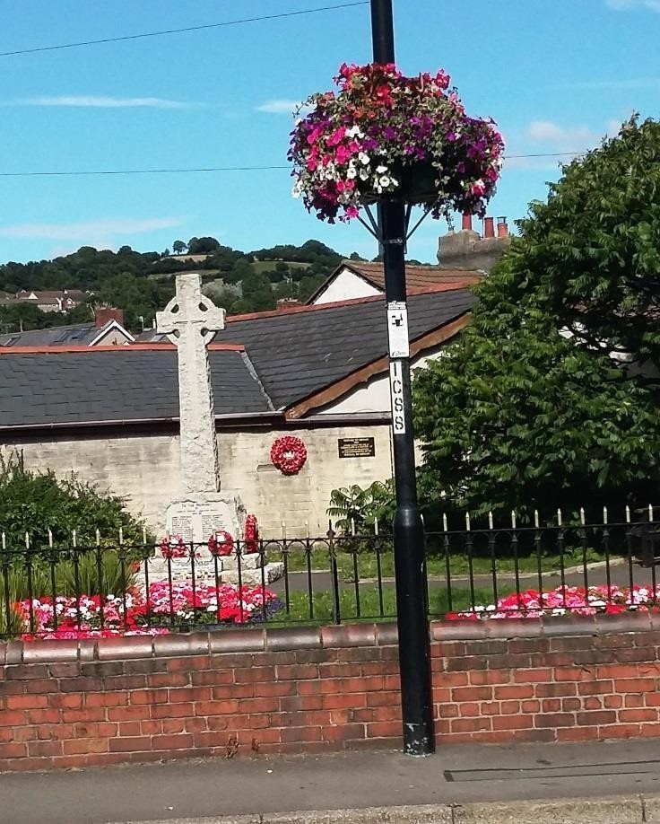
Risca Town Council’s summer basket display. This basket was located outside the Pontymister, Risca Cenotaph Garden, Tredegar Road, Risca

Risca Town Council’s daffodils display in Tredegar Park, Risca

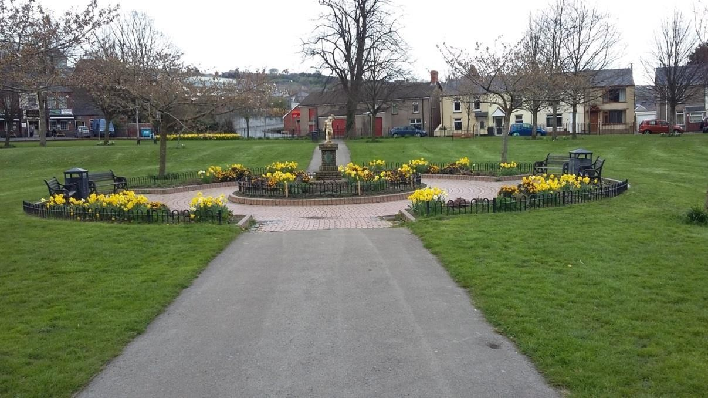

CONTENTS AND AIMS
Introduction Page 3
About Risca Town Council Pages 4 to 5
The Way Forward Pages 6 to 7
Appendix 1 Mayor/Chairperson’s Report Pages 8 to 15
Appendix 2 List of 2024 Projects Pages 16

The Town Council’s Aims:
- To promote the Town, its people, businesses and amenities
- To provide support to the Town to make it a prosperous and enjoyable place to live and work by maintaining and improving its well-being

Introduction
Welcome to this tenth Annual Report of Risca Town Council.
I hope that you will enjoy reading about the work of Risca Town Council and the people we serve.
I would like to thank the elected and coopted members of the Town Council for their hard work throughout the year.
I would also like to thank the many individuals and organisations who have worked with us to improve the well-being of the community of Risca Town.
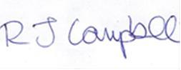
Bob Campbell, Risca Town Clerk
Email: clerk2riscatc@gmail.com or bob.campbell@riscatc.uk
Date: 13 July 2025

About Risca Town Council
Risca (Welsh:Rhisga) is a town of approximately 11,500 people in southeast Wales, within the Caerphilly County Borough and the historic boundaries of Monmouthshire. In 1996, to follow its county borough Ward boundaries, it was split into a division of East and West.
The Council was set up as Risca West Community Council alongside the neighbouring Risca East Community Council following local elections in late 2012.
Its inaugural meeting of eight elected Councillors was held in February 2013. The Caerphilly county borough council recognised the Council as having a ‘Town’ status in late 2013 and the name was duly changed to Risca Town Council to reflect this.
The Town Council area has a population of over 6,500 within its boundary that includes the Wards of Dan-y-Graig, Ty Isaf Fields, Town and Fernlea and Pontymister Lower.
The Council is made up of eight elected and coopted Town Councillors and one staff member, its Town Clerk.
The Council has steadily progressed with providing its Council business and local services where necessary since April 2013.
Details of the elected members and how to contact them are available at www.riscatowncouncil.org.uk. Notices of meetings, agendas, reports and minutes can also be viewed here, along with the governance, policy documents and other information about the Council and its business.
The Council derives almost all of its funds from its precept. That is an additional amount which is added to Council Tax bills based upon the Council’s estimated expenditure. For the 2024/2025 financial year it had an annual precept of £63,000. The Council has estimated that it needs to spend the majority of this amount on its service provision, commitments, local Projects and local donations. From the outset in 2013 the Council accepted the financial advice from its recognised partners that at least 30% of its annual income needs to be saved for future election purposes and as a Council reserve.
Further information about the Council’s finances, including its annual accounts is on the website.
This Report includes in Appendix 1 a summary of the Mayor’s year in office and Appendix 2 the Council’s services and Projects that are delivered to all age groups in a variety of forms from Christmas Festive lighting to summer flower baskets. These events contribute to the wellbeing of the Risca townsfolk.

The Way Forward for a Resilient and Competent Risca Town Council What we think we did well:
Our members closely monitor the way the Council is run to ensure we use our resources wisely.
We have strong links with Risca East Community Council, Caerphilly County Borough Council, Gwent Police and our local businesses to help contribute to the continued regeneration of Risca.
We keep neighbourhood services matters under particular scrutiny. We encourage positive attitudes to sustainability and environmental issues, especially amongst our young people.

What we think we could do better:
We will continue to look at ways of working with the townsfolk and local businesses in our community to encourage sustainability. We will work with our partners to make the best use of our resources.
We will seek the inclusion of our younger townsfolk at our council meetings and events organising sub-committees.
We want to encourage more members of the public to attend our events. We will make this a priority for the future.
We will strive to keep our working practices environmentally friendly, supporting sustainable approaches to recycling, waste management and use of resources.
Risca Town together with the 17 other Town and Community Councils of Caerphilly County Borough commit to working in an environmentally friendly way, to take into account the environmental impact of any goods or services we source, to promote reduce, reuse and recycle programmes, to look at contributing to sustainable planting and preserving biodiversity, to raise awareness of the impacts of climate change and foster relationships between the community, local businesses and the local authority as to how we can work together to find shared solutions. We will take into account those biodiversity concerns and requirements as set out by Welsh Government in all our decision making.
Finally, we face many new challenges and opportunities. The Town Council is aware of the recent Boundary Commission’s Report to change several of the Ward and Community boundaries within the Caerphilly County borough and of its plan for Risca to be reunited as one Community, after it was split up into East and West Wards in 1996. Welsh Government has recently agreed to that Report and the Town Council and Risca East Community Councils will be closed down and a new Risca Community Council will be set up, most likely in time for the May 2027 Local Government elections. It is important that the current Town Council is ready to face this opportunity and other challenges to be Fit for the Future via a number of ‘competency’ tests that are emerging to help us determine how well equipped we are to meet the challenges ahead. These tests will bring more consistency to the sector with higher standards of governance and financial management. These tests may include: a democracy test, a capability test and a governance test. The Town Council already has sound financial management and internal control systems in place, regularly publishes our agendas, minutes and accounts on our website and is contactable by email, phone and the social media of Facebook, Twitter and Instagram.
The Town Council continues its essential business via in person Council meetings (with remote virtual access available only upon prior notification, of at least 3 days, with the Town Clerk). We acknowledge the Welsh Government rule for ‘hybrid’ - in person and virtual – Council meetings together and with the community.

Appendix 1 - Mayor/Chairperson’s Report
I am proud to have been elected Mayor/Chairperson and have very much enjoyed representing the Town Council for a second term over the last 12 months.
We have a strong team of Councillors who together with our Clerk all share the same common interest of improving our community. We continue to welcome suggestions from fellow residents and will always strive to improve the Town and the services available to us all. We continued to enjoy a very good working relationship with our County Borough Councillors, Bob Owen and Ceri Wright through 2024.
There are of course many individuals and organisations who have worked with us to improve the well-being of Risca Town and it is great to see so many local residents both young and old taking an interest in our activities and services.
During the last year we were again able to carry out our main projects of summer flowers and hanging baskets, Christmas festive lighting and Christmas Tree lighting plus a major Winter Fair with a lighting/music event in the Town that was fully supported and enjoyed by the families and friends in Risca. We again supported the 8 street planters, the two 4-tier planters and those hanging basket sites in the summer of 2024. We added a further 6 new Festive lighting lanterns for Christmas 2024 to now total 41 lanterns and these were greatly appreciated by the Risca residents. We again held a Christmas Shop Window competition in 2024.
We look forward to our projects for 2025 which include:
- Bands in the Park – Sunday afternoon on 20 July with the local Cross Keys Silver Band
- Armistice Remembrance Concerts and events
- Festive Winter Fair/tree lighting event – tea party with live music on Saturday 22 November

Finally, we have supported local charities and organisations with donations during the year. It has been a privilege to support the wonderful work that they do. These included:
- Air Ambulance Wales
- Llamau Charity
- Pontymister Bowls Club
- Air Cadets
- Risca’s Primary Schools
- Crosskeys Silver Band
- Risca Male Voice Choir

Councillor Mike Parker
Mayor of Risca Town Council – 13 May 2024 to 11 May 2025

The following photographs are from some of the projects the Council carried out in 2024:


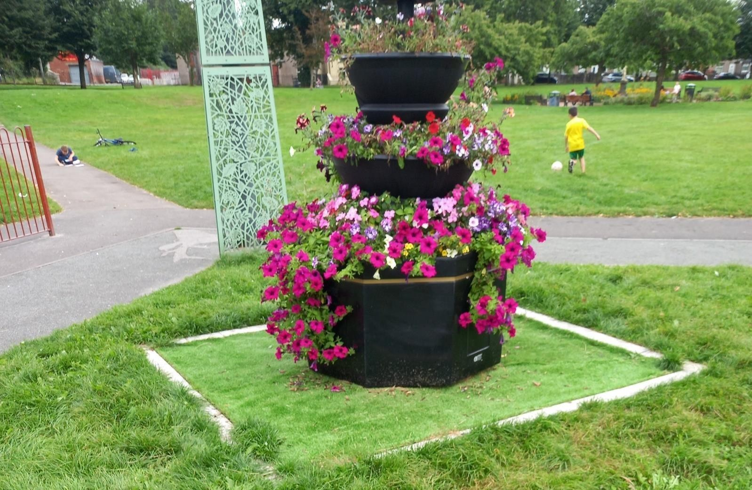
One of the 4-tier planters presented by Risca Town Council for its summer flowers and planters project

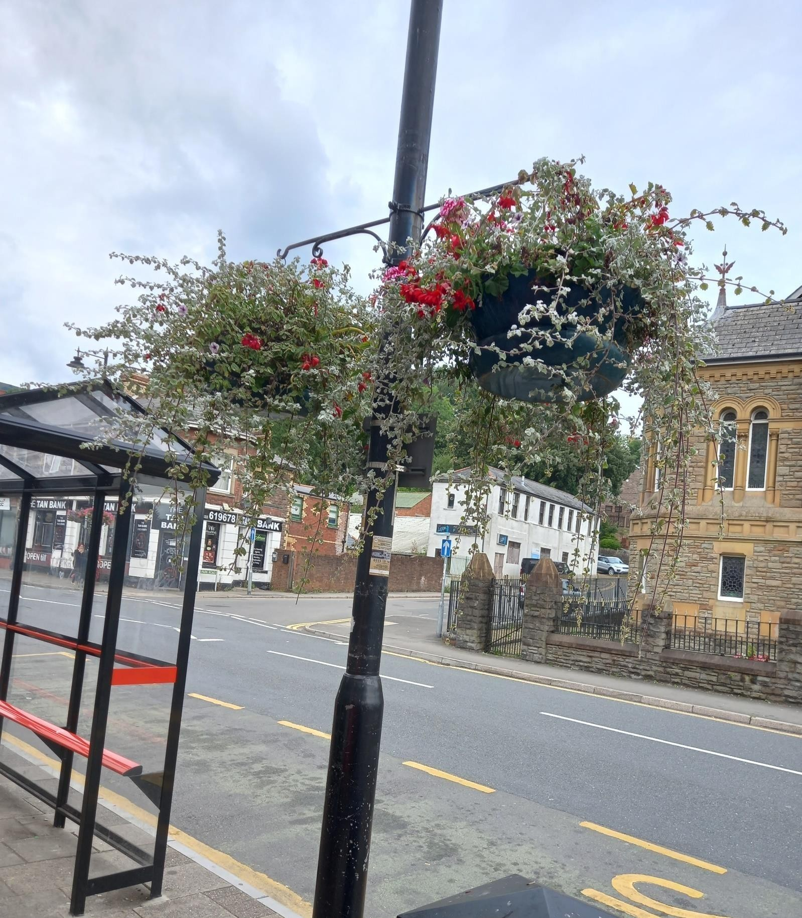

Risca Town Council’s summer baskets project

One of Risca Town’s summer planters
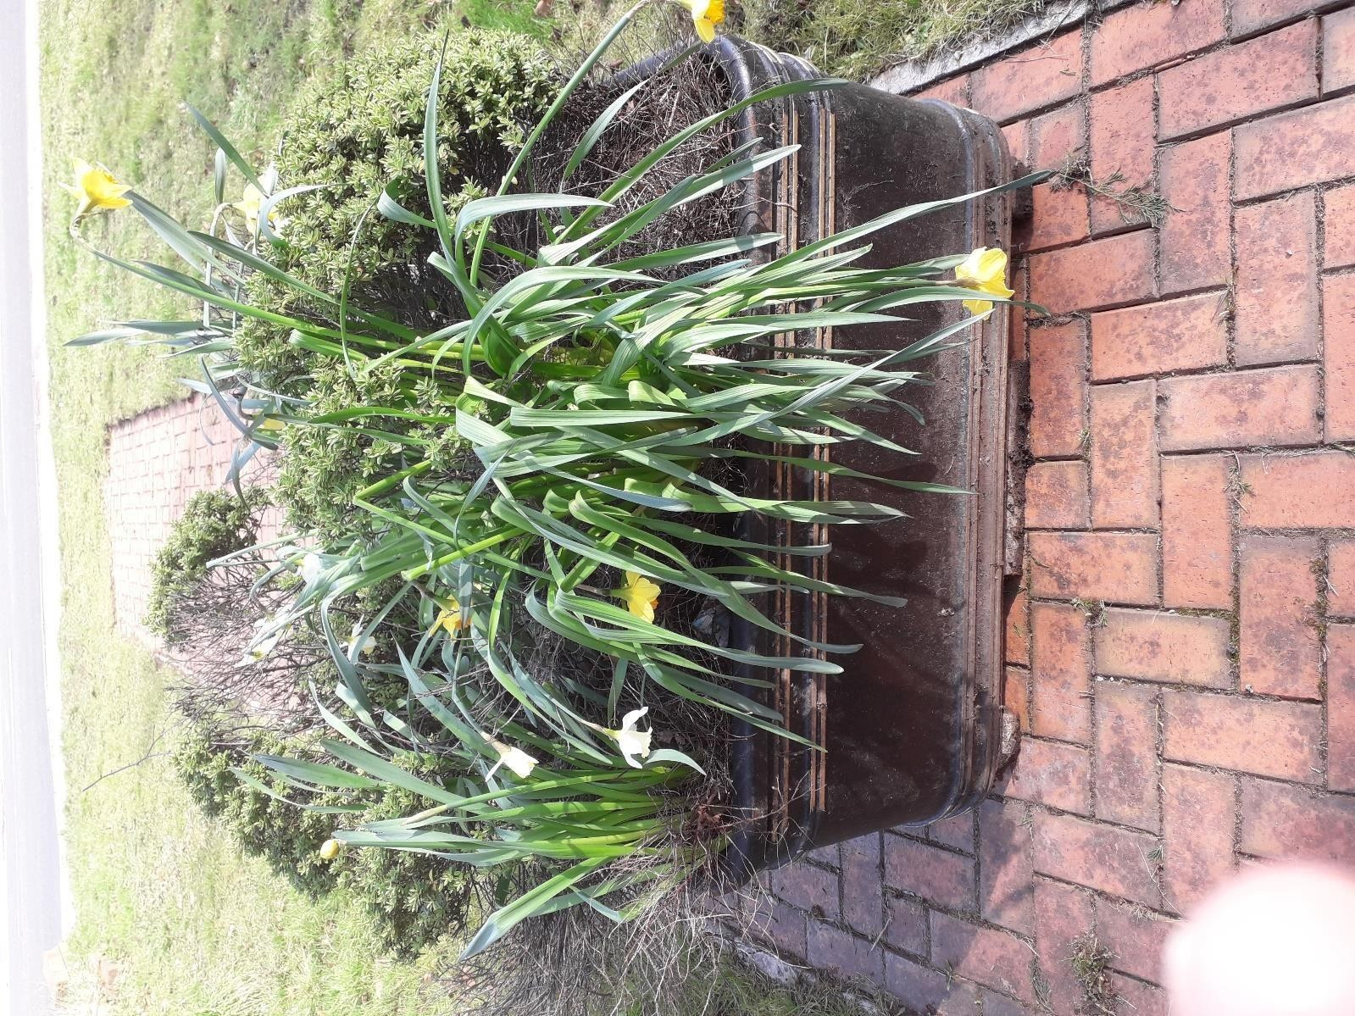

Photos of the Risca Town Council’s Winter Fair in Tredegar Park, Risca on Saturday 30 November 2024 (The Town Council wish to thank Caerphilly county borough council’s Parks Department for their permission to use Tredegar Park, Risca)
Risca residents enjoying the Christmas Tree lighting event and Risca Town’s celebrities ‘Jagger and Woody’s’ Festive entertainment programme
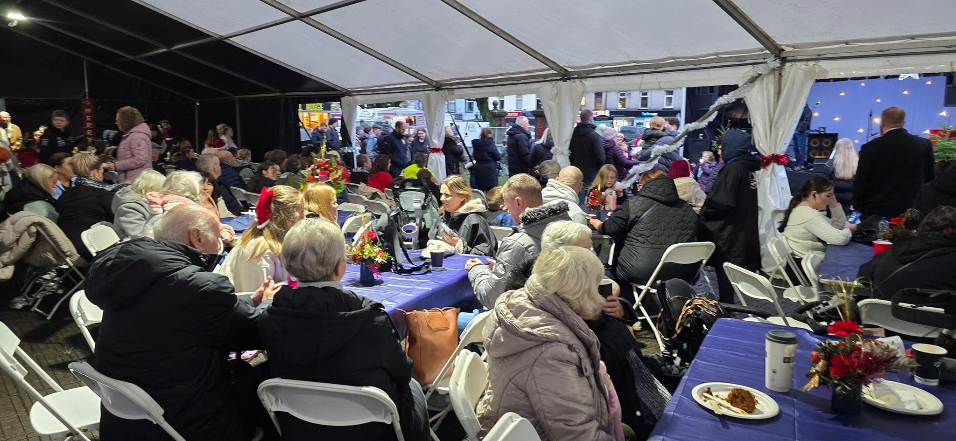

Santa in his Grotto at Risca Town Council’s 2024 Winter Fair
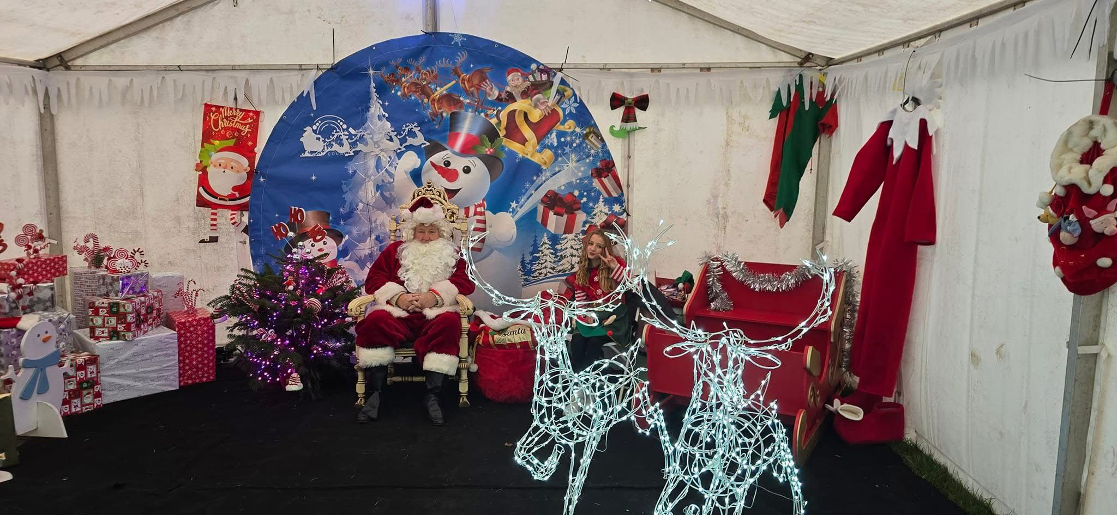
Guest singers at the Town Council’s Winter Fair 2024
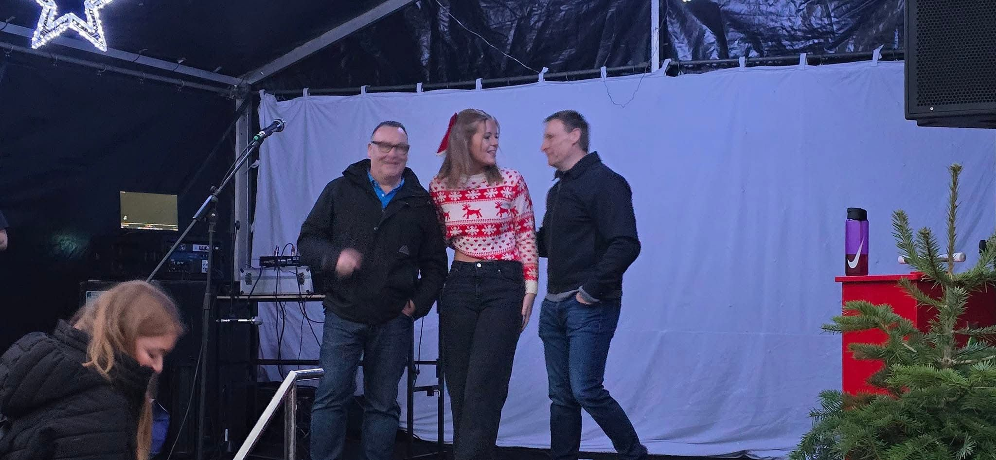

The Grinch character at the Risca Town Council’s Winter Fair 2024
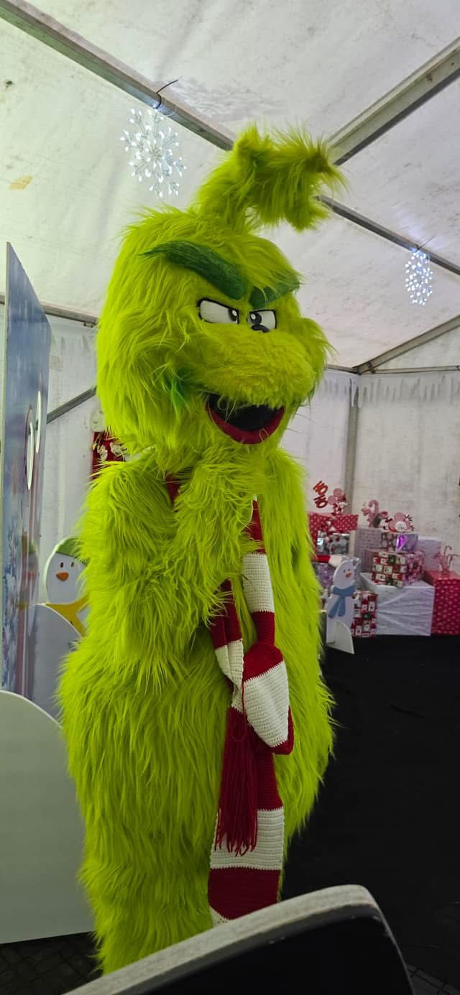

Risca Town Mayor Cllr Mike Parker was invited to open the Risca Banking hub in September 2024
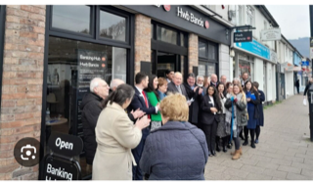

Risca Town Council Mayor Cllr Mike Parker and Risca Town Cllr Sally Davies thanking the owners of the local Butcher’s shop, Chris and Natalie Powell for their service to Risca before retiring in September 2024
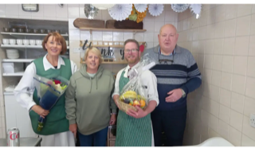

Risca Town Council’s Bands in the Park event with Crosskeys Silver Band on Sunday 21 July 2024

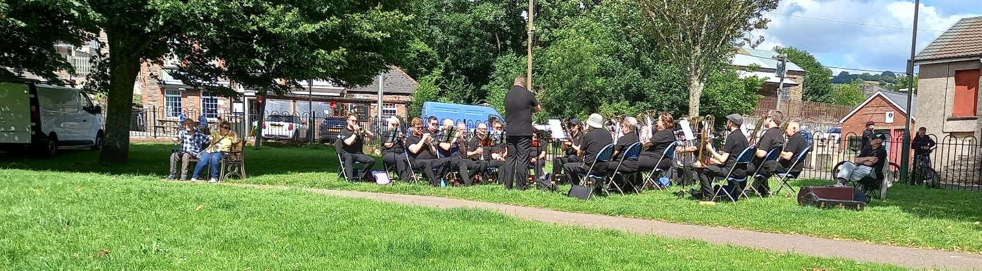

This a photo of the bluebells on the Ochrwyth mountainside just outside Risca Town


Appendix 2 - Risca Town Council - All Projects summary for 2024

 | Page  1
  Project No. | Project Name | Description & Comments | Amount Paid | Amount Pledged
  1 | Bands in the Park – Event | arranged for summer 2024 | 0 | 600
  2 | Summer flower baskets and planters 2024 | Local contractor to:  1/ erect summer baskets and brackets on lighting columns  2/ replant, maintain and water summer planters  3/ replant, maintain and water autumn planters |  | 8000
  3 | 1/ 7.00 pm Fri 8 Nov  Remembrance Service at Moriah Church 2024  2/ 11.00 am Sat 9 Nov  2/ Parade - 10.30 am  Sunday 10 Nov | Risca Town and Risca East joint  Remembrance Services  JOINT EVENTS |  | 1000
  4 | Christmas 2024 Festive lighting contract | Project contract a power supply and energy charge |  | 5000
  5 | Christmas Tree lights switch on event in Park | With barriers, lights teas/coffees/cakes and entertainment |  | 10000
  6 | Christmas 2024 window dressing | 3 prizes |  | 300
  A | POSSIBLE - Wild flower planting | To be added to CCBC enhancement project for spring/summer 2024 |  | 300
  Total |  | Approximately |  | 26,000

